ASSIGNMENT-2

TASK-1
CREATE TABLE task_1 (
EmployeeID SERIAL PRIMARY KEY,
FirstName VARCHAR(50) NOT NULL,
LastName VARCHAR(50) NOT NULL,
Email VARCHAR(100) UNIQUE NOT NULL,
PhoneNumber VARCHAR(15) UNIQUE,
HireDate DATE NOT NULL,
Salary DECIMAL(10, 2) CHECK (Salary >= 0),
DepartmentID INTEGER NOT NULL,
IsActive BOOLEAN DEFAULT TRUE,
JobTitle VARCHAR(100) NOT NULL
)
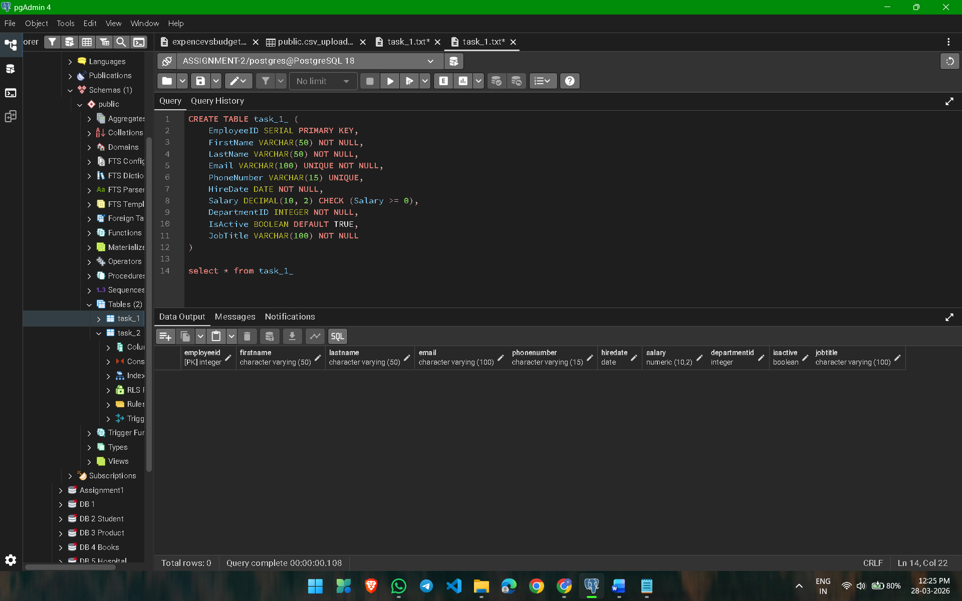

TASK-2
INSERT INTO task_1
(FirstName, LastName, Email, PhoneNumber, HireDate, Salary, DepartmentID, IsActive, JobTitle)
VALUES
('Vaishnavi', 'Gajbhiye', 'vaishnavi.gajbhiye@example.com', '9890123456', '2023-03-22', 42000, 2, TRUE, 'HR Executive'),
('Saurabh', 'Meshram', 'saurabh.meshram@example.com', '9765432101', '2021-11-10', 61000, 1, TRUE, 'Network Engineer'),
('Pooja', 'Bawane', 'pooja.bawane@example.com', '9876543212', '2020-08-05', 47000, 3, FALSE, 'Account Assistant'),
('Nikhil', 'Kapse', 'nikhil.kapse@example.com', '9811122233', '2024-01-18', 55000, 2, TRUE, 'Marketing Analyst'),
('Swapnil', 'Wankhede', 'swapnil.wankhede@example.com', '9823012345', '2022-05-14', 50000, 1, TRUE, 'Software Developer')

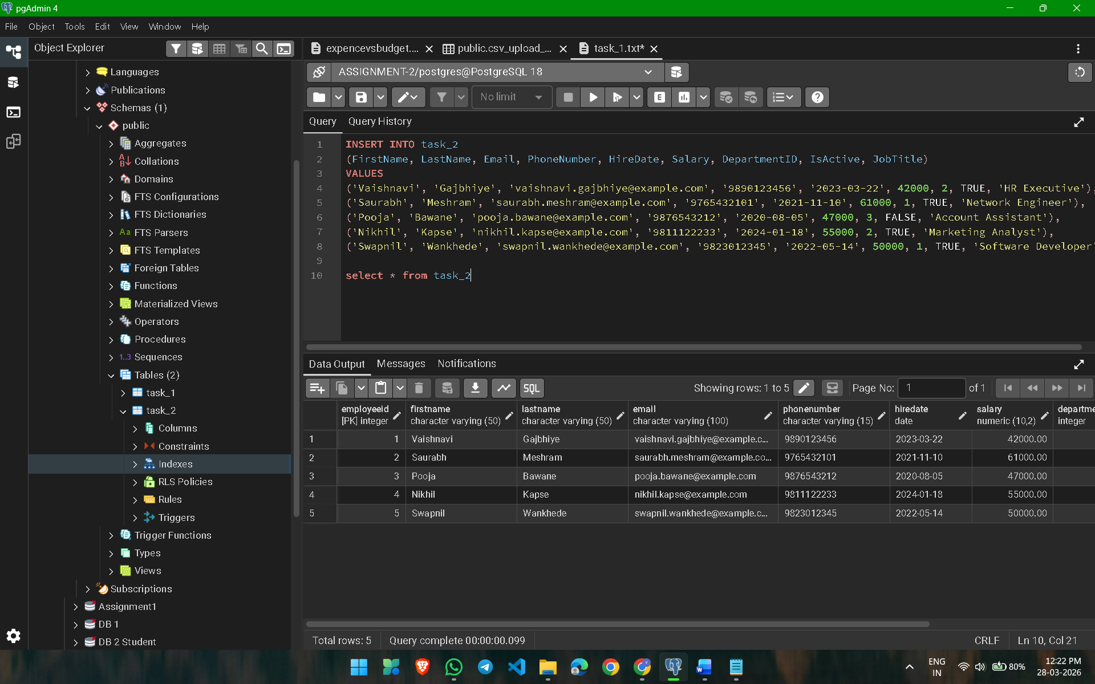

TASK-3
CREATE TABLE products_table (
product_id INT ,
product_name VARCHAR,
category VARCHAR,
price INT,
stock_quantity INT,
supplier_name VARCHAR,
supplier_city VARCHAR,
supply_date DATE
)

copy products_table from 'D:\SQL\csv_files\products.csv' delimiter ','
csv header

select * from products_table

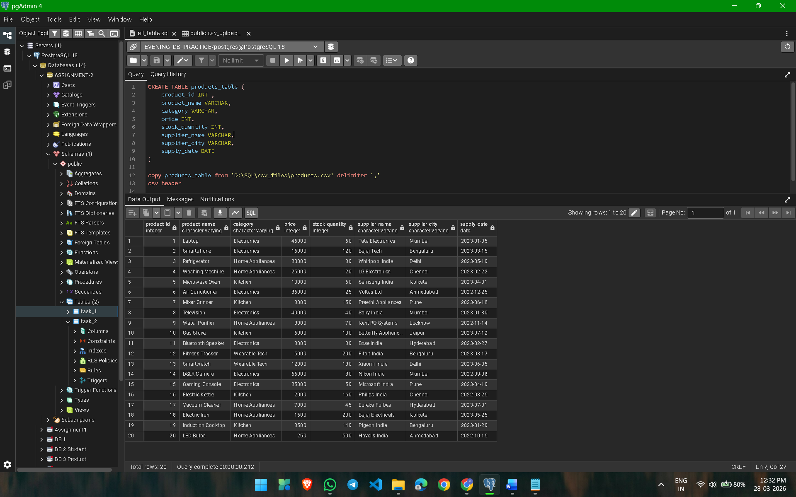

TASK-4
UPDATE employee_deetails_table
SET department = 0
WHERE isactive = FALSE;

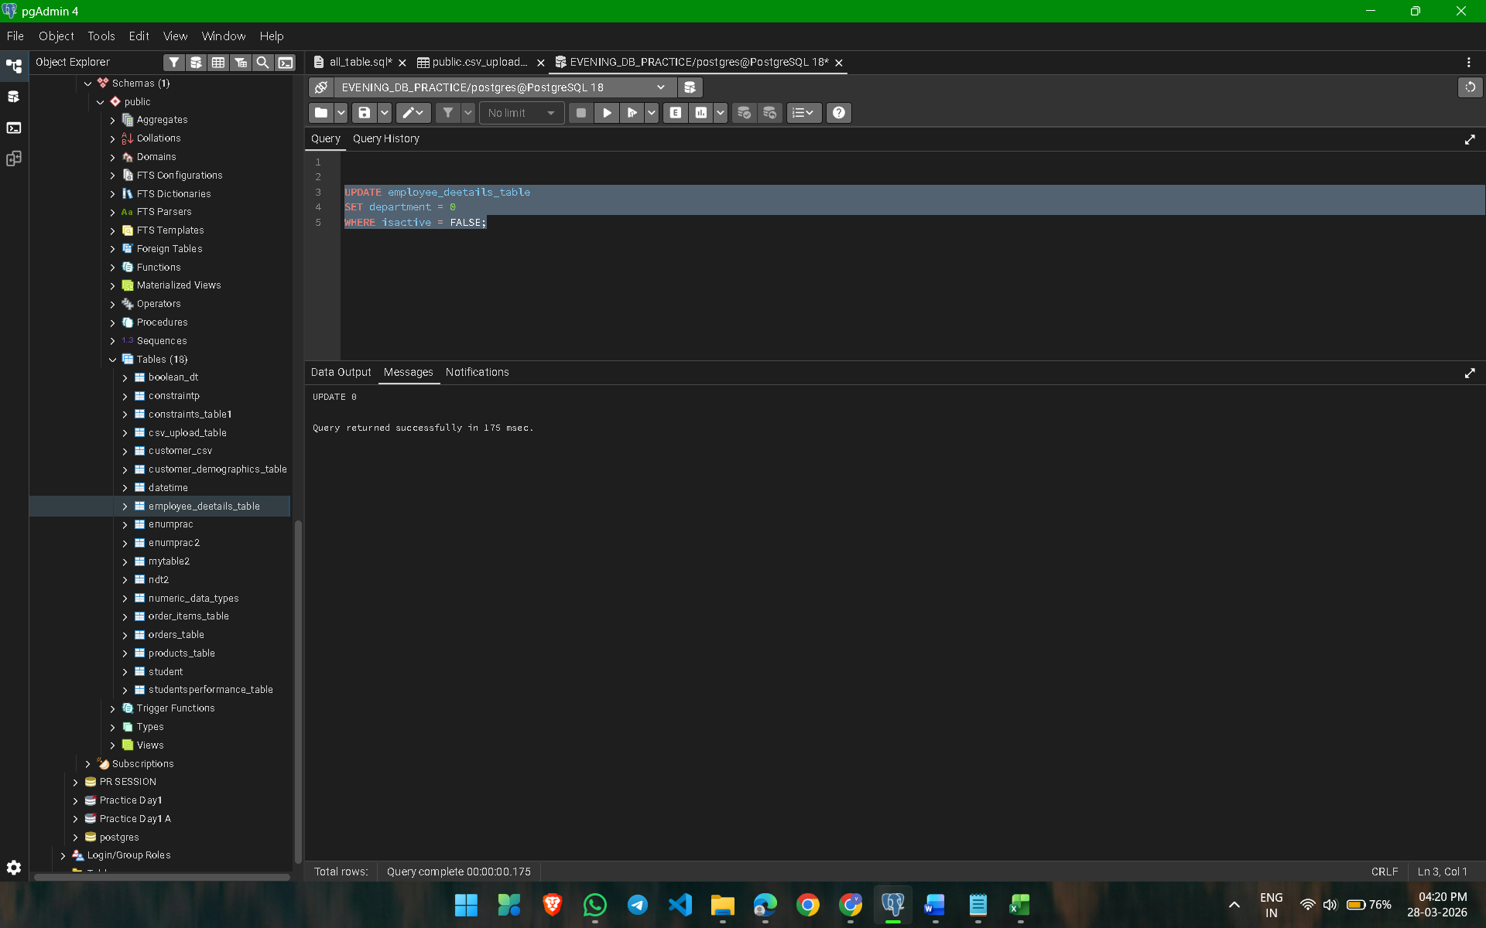

TASK-5
UPDATE employee_deetails_table
SET annual_salary = annual_salary * 1.08
WHERE isactive = TRUE
AND job_title = 'Account Representative'
AND department = 'Sales';

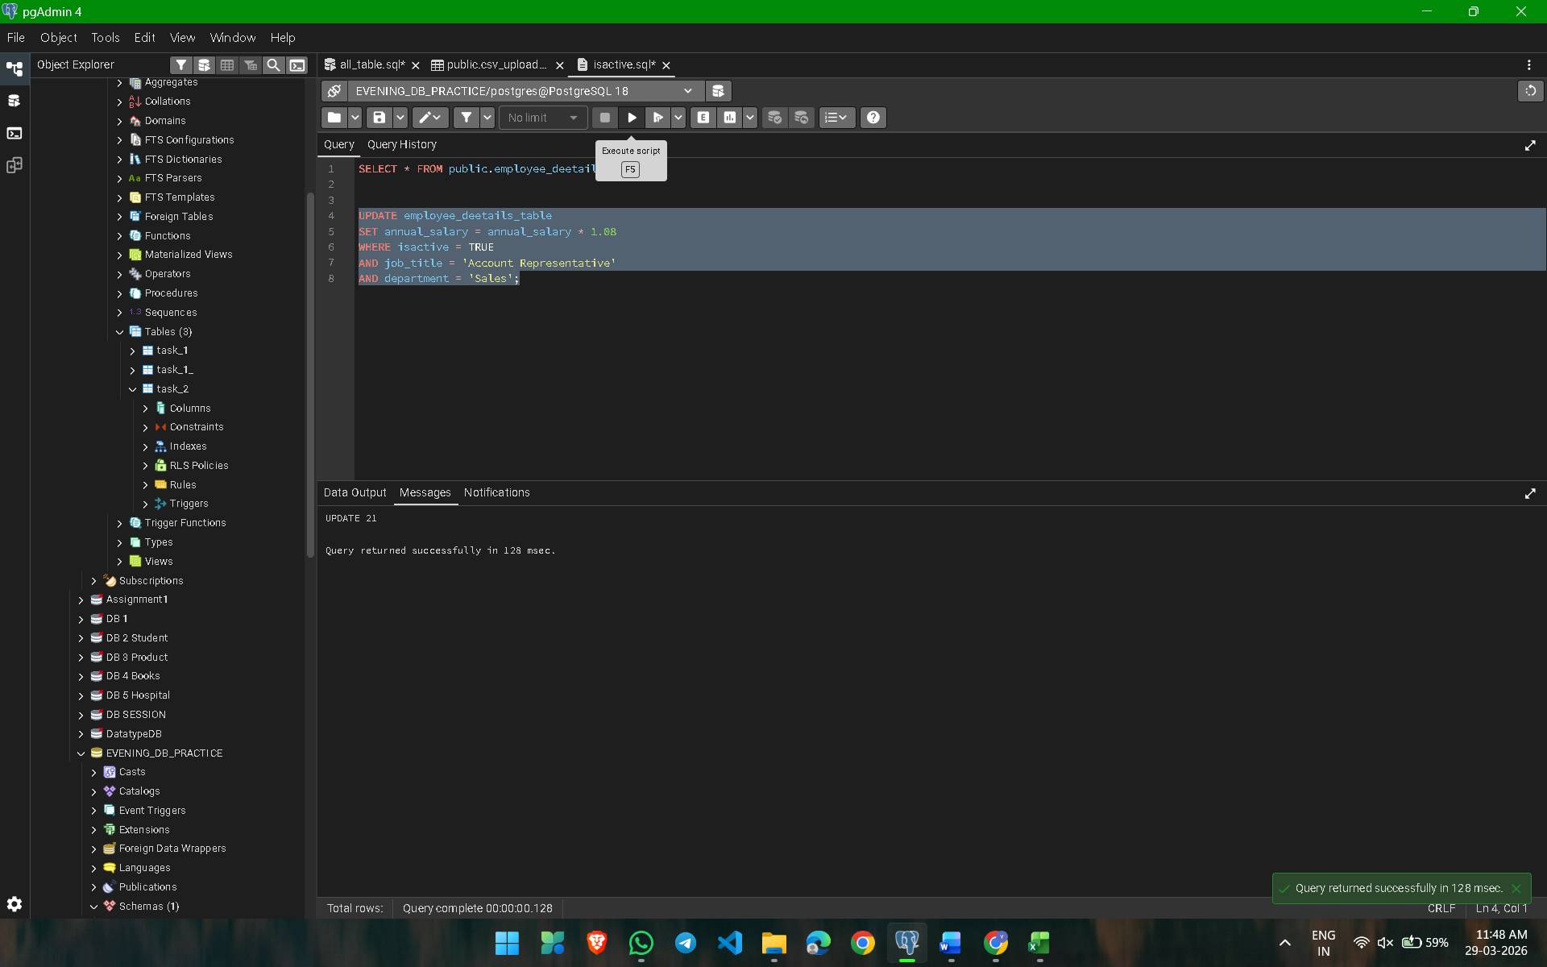

TASK-6

SELECT
full_name AS Name,
business_unit AS business_unit_emp
FROM employee_deetails_table
WHERE annual_salary BETWEEN 30000 AND 50000;
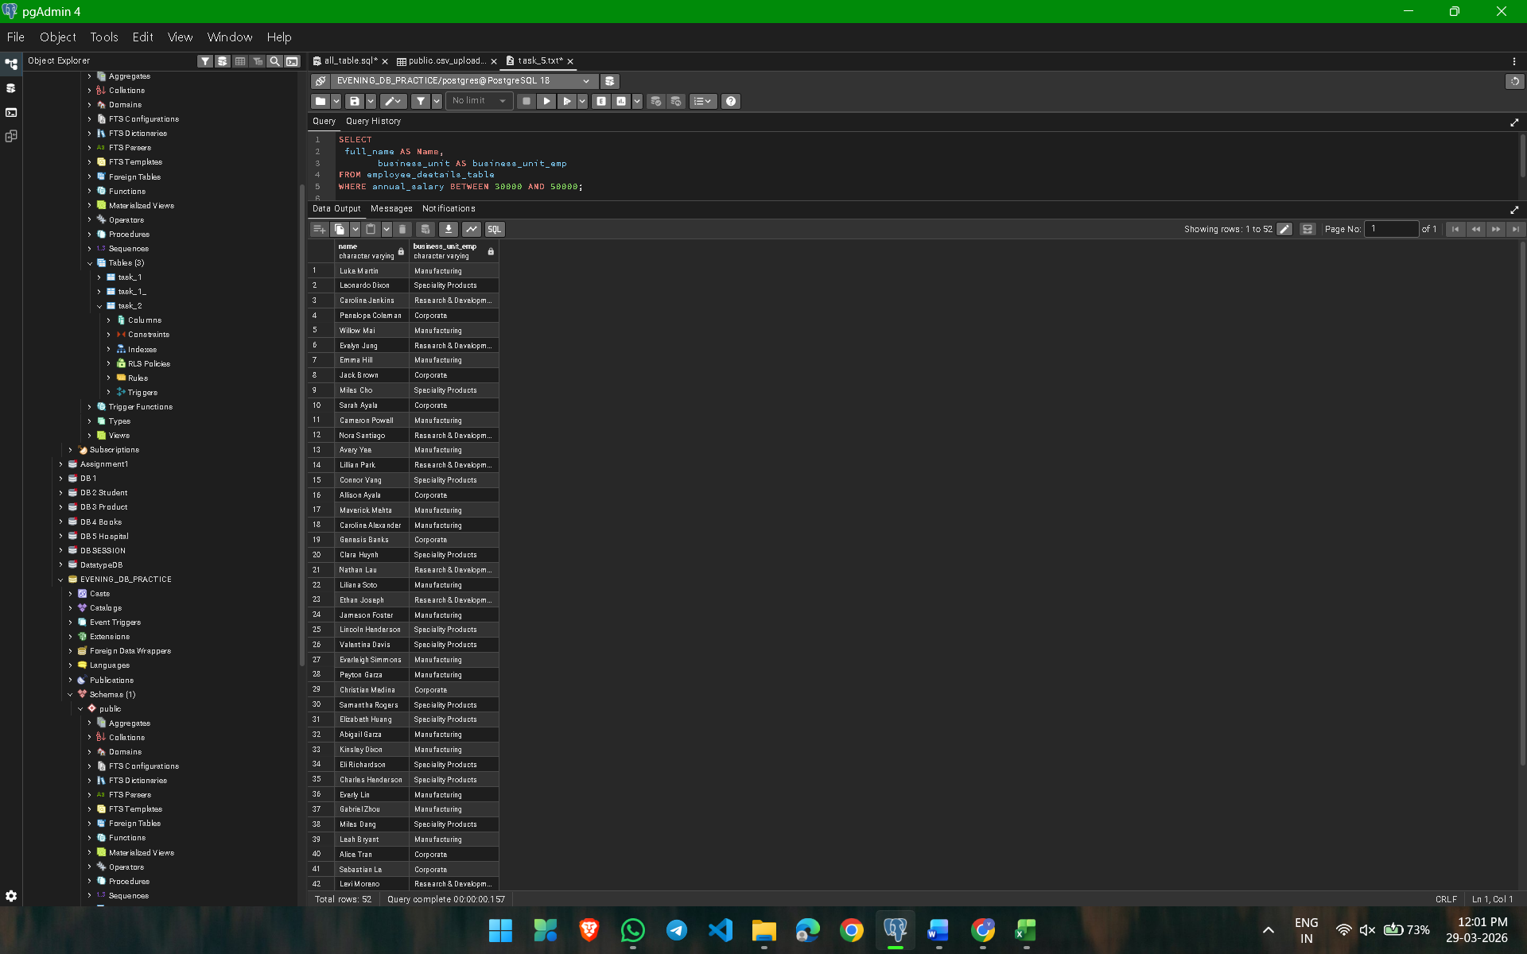

TASK-7

SELECT *FROM task_2
WHERE firstname LIKE '%v%';
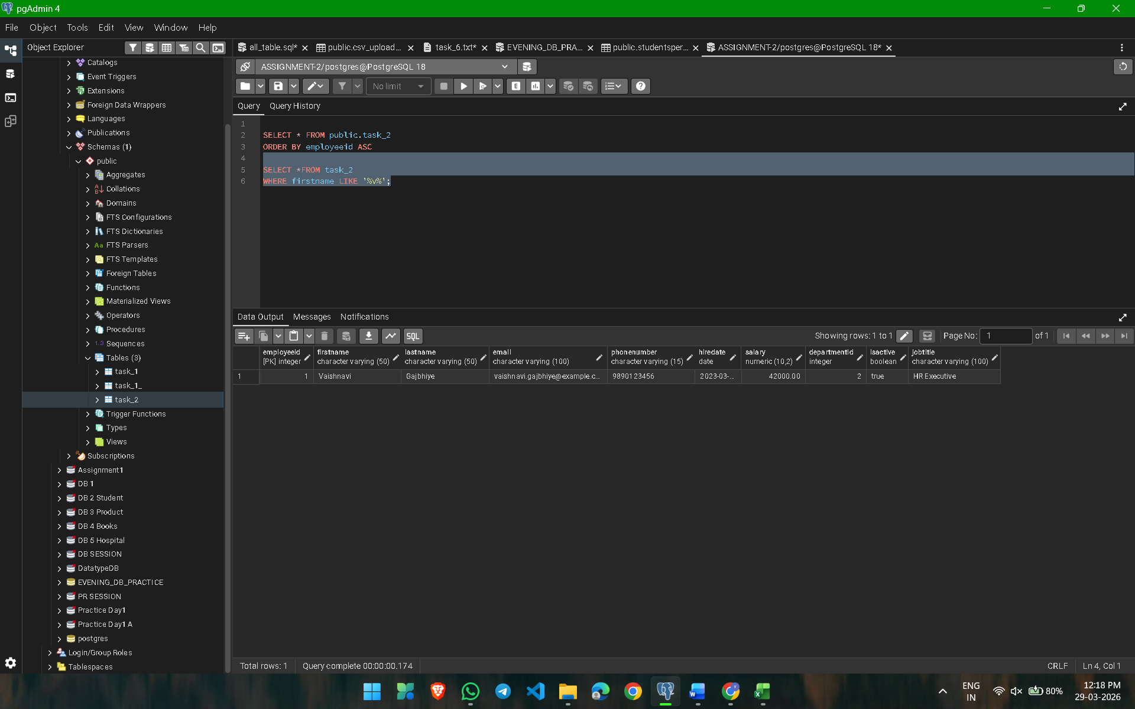

TASK-8

DELETE FROM studentsperformance_table
WHERE student_id BETWEEN 1 AND 5;

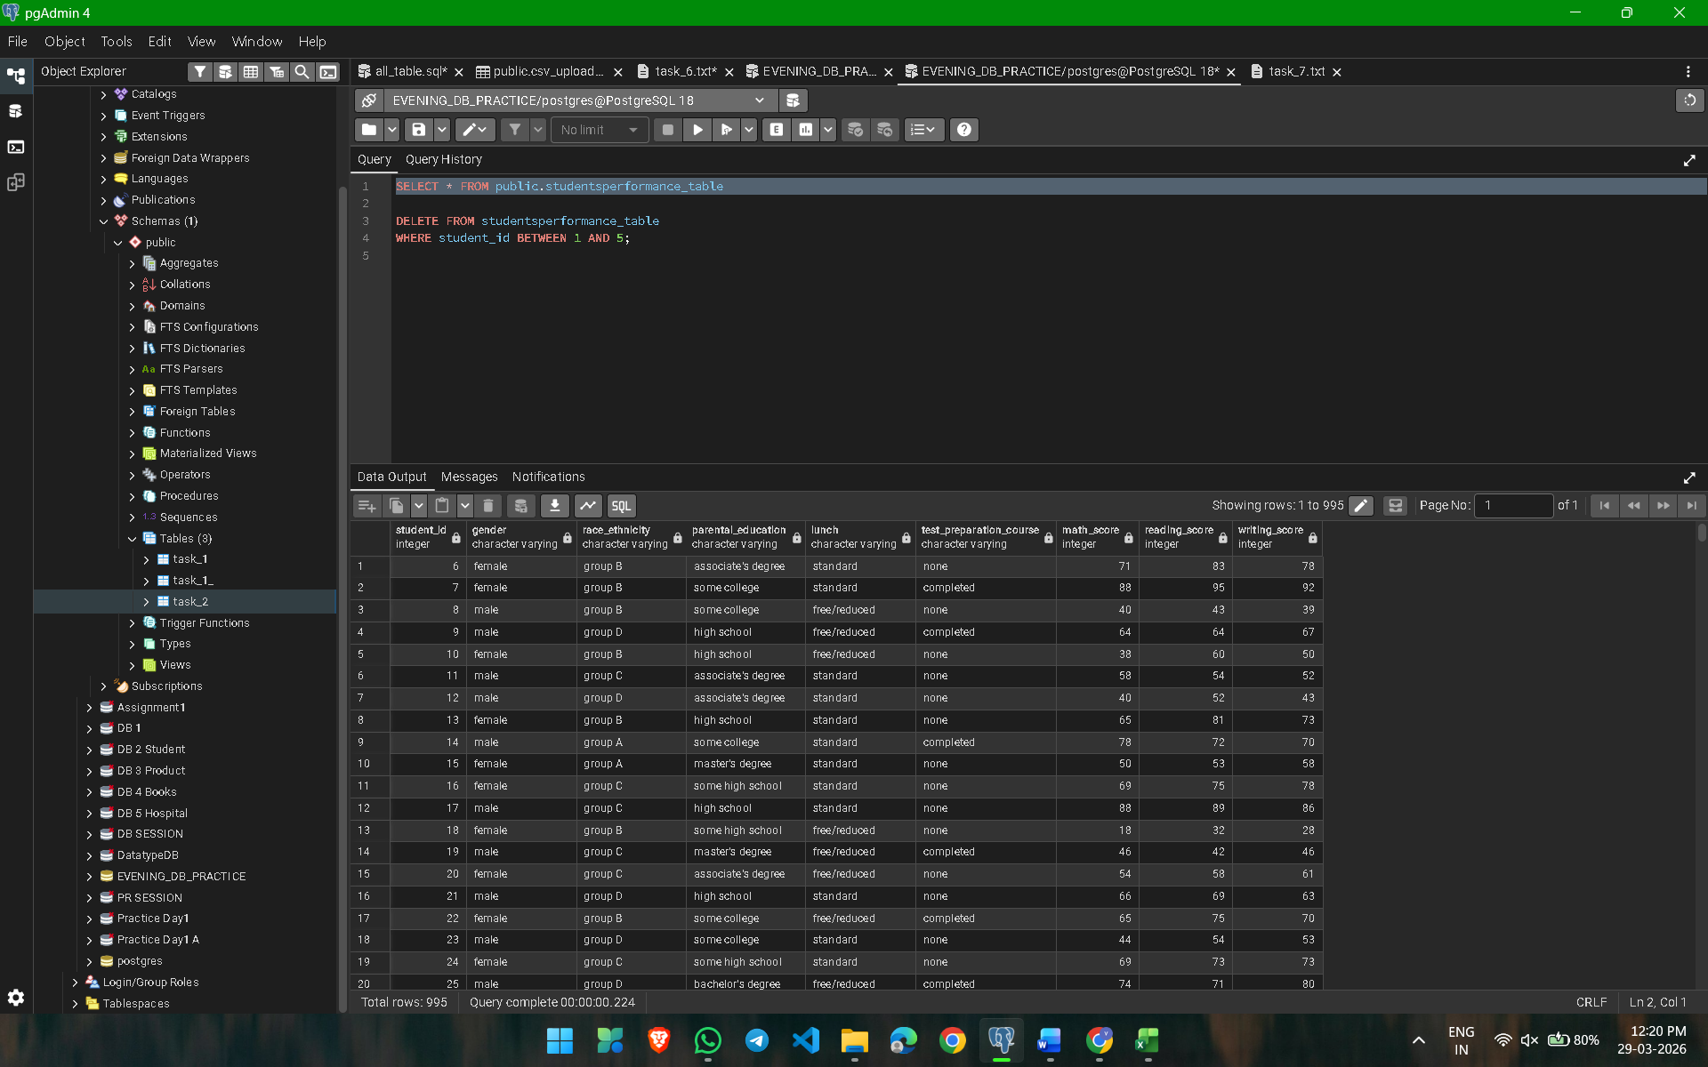

TASK-9
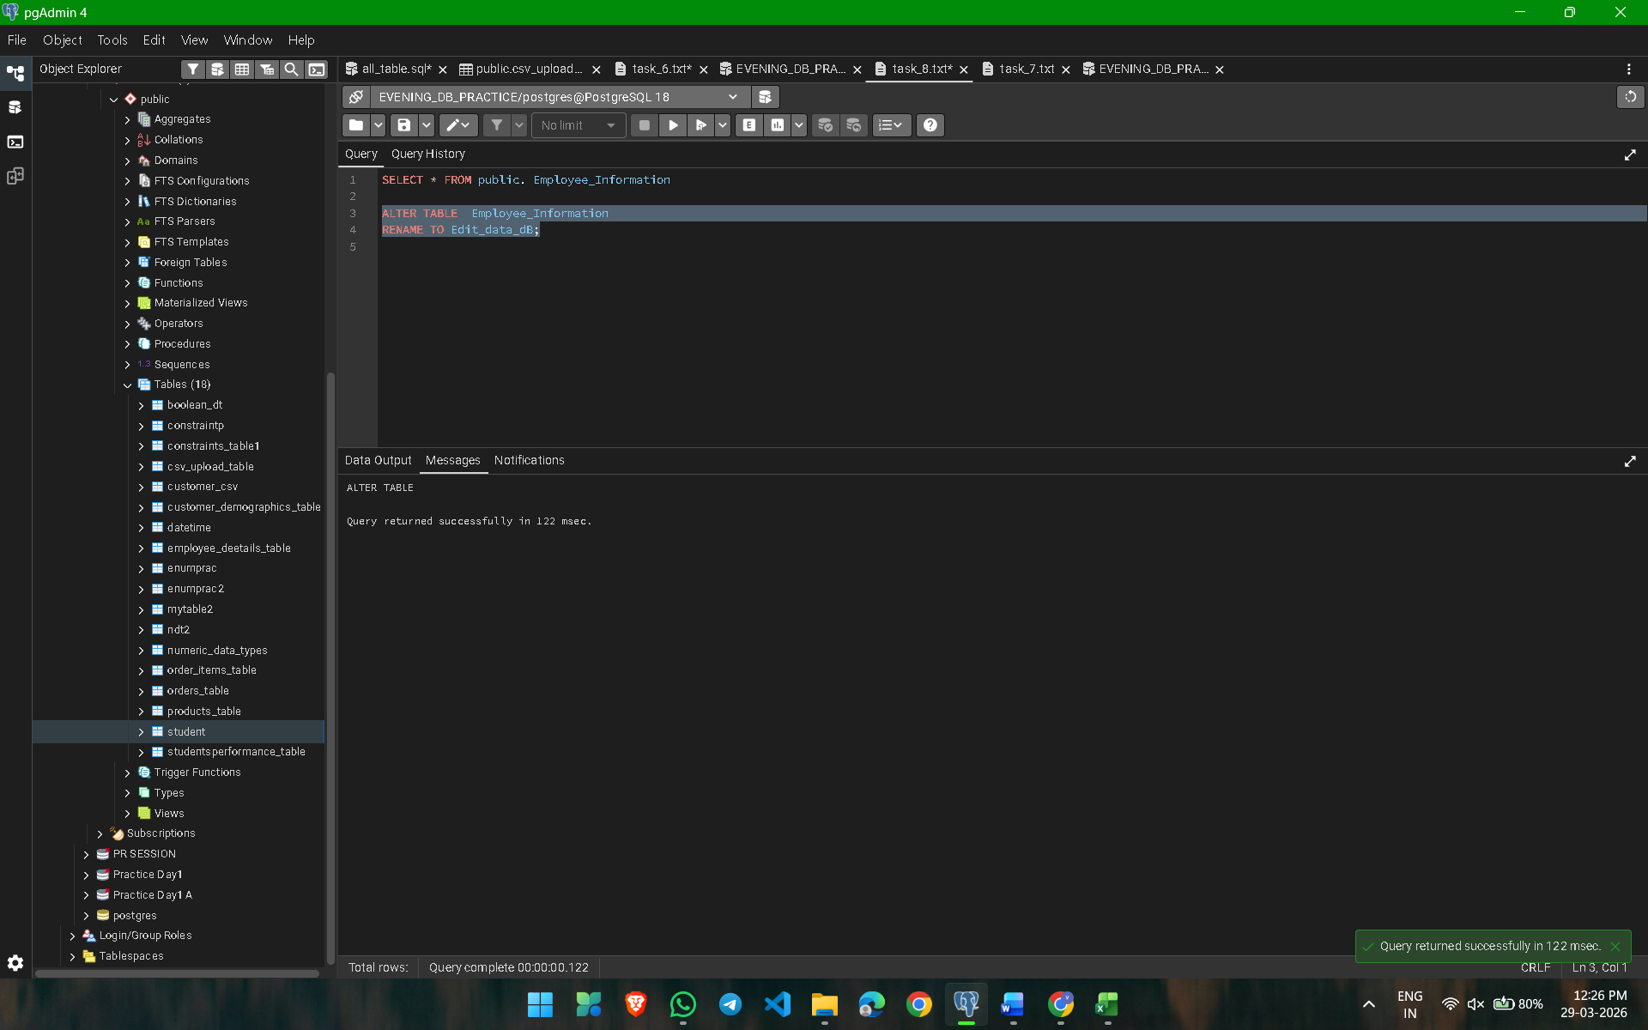

ALTER TABLE Employee_Information
RENAME TO Edit_data_dB;

TASK-10

ALTER TABLE employee_deetails_table
ADD COLUMN state VARCHAR;

UPDATE employee_deetails_table
SET state = CASE
WHEN isactive = TRUE THEN 'India'
ELSE 'USA'
END;

